Adding a Drawing Template Solid Edge

Make a copy of the RR Drawing Template off Github.

Go to:

Program Files > Siemens > Solid Edge 2020 > Template > ISO Metric

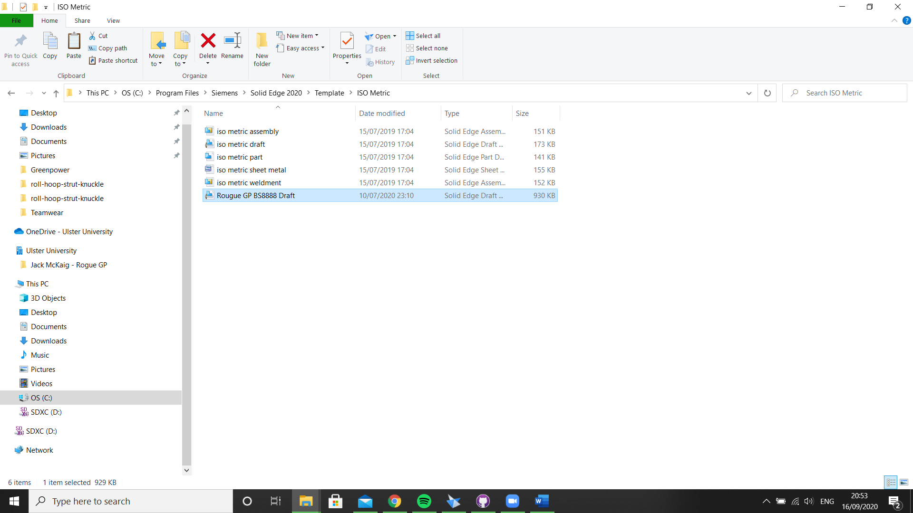

Paste Drawing template into this file and check Solid Edge to see if it has been added successfully.

